Title IIA Shared Service Consortium
Travel Conference Request Form

Date of Request:
School Name:
Employee Name:
Sponsor of conference:
Location of conference:
Purpose of conference:
Announcement info:

Dates of conference:
Travel departure date/time:
Travel return date/time:

ALL ORIGINAL RECEIPTS ARE REQUIRED FOR REIMBURSEMENT

Estimated expenses | Description |  |  | Amount to be reimbursed
Auto Mileage | _____ miles @ _____ (IRS Rate – effective 1/15)
Transportation (air/train/car rental)
Local transportation (taxi/shuttle/car rental
Parking/Tolls
Lodging | Name and address:  □ Not applicable
Meals
And/or Meals breakdown | Breakfast _____ @ _____ = ______  Lunch _____ @ _____ = ______  Dinner _____ @ _____ = ______  Incidentals _____ @ _____ = ______
Registration fee | Paid to:
Other fees
Miscellaneous
TOTAL COST
_____________________________________  Employee Signature |  | _________________  Date
Approved by:

_____________________________________  Supervisor |  | _________________  Date
Title IIA Shared Consortium:  Approved by:  _____________________________________ |  | _________________  Date

TRAVEL CONFERENCE REIMBURSEMENT REQUEST

DATE: _________________ REQUEST #___________________________

SCHOOL NAME: _________________________________________________

NAME: __________________________________________________________

TRIP DATE(S): _______________________ CITY/ST: ___________________

DATE/TIME LEFT: ________________________________________________

DATE/TIME RET: _________________________________________________

REIMBURSEMENT FOR (*-Receipts/statements required)
Description | Reimbursement  Requested
Auto Mileage (____ @ _______)
*Transportation(air/train/car rental)
*Additional transportation (taxi/shuttle)
*Parking/Tolls
*Lodging
*Additional Lodging
Meals: (per diem rate per day)
# days ______ @ ______
Breakfast - #______ @ ______
Lunch - #______ @ ______
Dinner - # ______ @ ______
Incidentals - #______ @ ______
*Registration Fees
*Other (please detail)
Reimbursement Total
Total Cost of Conference

_____________________________________  Employee Signature | _________________  Date
Approved by:

_____________________________________  Supervisor | _________________  Date
Title IIA Shared Consortium:  Approved by:  _____________________________________ | _________________  Date

Title IIA Shared Service Consortium
TRAVEL CONFERENCE DETAILS

Travel Conference Details - Auto

No receipts required.

Auto mileage is reimbursed to employees whose job duties require them to use their personal automobiles in the performance of their duties. This reimbursement follows the contract for each employee.

Reimbursement will be at the current IRS rate, which is $.535 per mile for the 2017 fiscal year.

Note: Travel over 300 miles per round trip must be by public carrier unless it can be demonstrated that automobile travel will be more economical with respect to the following: time involved, the cost of lodging and meals, the existing mileage allowance, and accessibility of the destination by public carrier.

The New York State Office of General Services (OGS) has granted Enterprise Rent-a-Car a rate increase of 2.02% effective on August 23, 2010. This rate increase is based on data from the latest Consumer Price Index according to OGS.

Travel Conference Details - Transportation (air/train/car rental)

Receipts required.

When traveling by air, employees must use the lowest commercial carrier rates available. Any additional items on the airline ticket, such as insurance, will not be reimbursable. Contact your administrator regarding obtaining a sales tax-exempt form.

Travel Conference Details - Ground Transportation

Receipts required.

Example of additional transportation: taxi from the airport/train station; shuttle service. This generally covers transportation costs incurred once you arrive at your destination.
Travel Conference Details - Parking/Tolls

Receipts required.

One item that should be listed here is tolls. Receipts are required. If you use EZ PASS, you may attach the on-line version or the mailed monthly version of your bill. In either case, you must highlight the toll amounts being claimed on this Travel Conference form.

Travel Conference Details - Lodging

Receipts required.

New York State sales tax for lodging cannot be reimbursed. Purchase orders should be printed with the school’s tax-exempt number printed on them. If you are not using a purchase order for lodging, check with your administrator about obtaining a tax-exempt form. Before checking out, obtain an original receipt showing a zero dollar balance to attach to your reimbursement claim form.

If your lodging costs are not going to be reimbursed, check the box marked Not Applicable.

Additional Lodging should be used for overnight travel involving multiple lodging sites.

Travel Conference Details - Meals

No receipts required.

Expenses for meals during approved overnight travel will only be reimbursed according to the schedule shown below. Alcohol is not reimbursable. No reimbursement for meals will be permitted for one-day conferences or travel or if the meals are included in the workshop or conference.

Effective March 1, 2004 meal expenses for overnight travel will only be reimbursed based on a per diem rate as outlined below. Expenses for overnight-approved travel will be reimbursed when accompanied by original receipts for lodging and other reimbursable expenses.

The United States General Services Administration publishes on the following website the per diem meal rates for all major cities in the United States. Click on link below.
http://www.gsa.gov/portal/category/21287

The following table lists the current per diem rate for some of the major New York regions along with an explanation of the breakdown of these per diem rates. The Incidental Expenses rate of $5 reimburses people for minor expenses such as coffee. For out-of-State travel, please call the Business Office for rates.

These rates will be reviewed on an annual basis, and any appropriate changes will be made.

If claiming breakfast the first day and/or dinner the last day, evidence MUST be turned in that the employee left before 6:00 AM and/or returned after 6:00 PM (i.e. airline itineraries, parking ticket, toll receipt)

To receive meal reimbursement, employee needs to submit proof that they attended the conference (i.e. agenda, certificate of attendance).

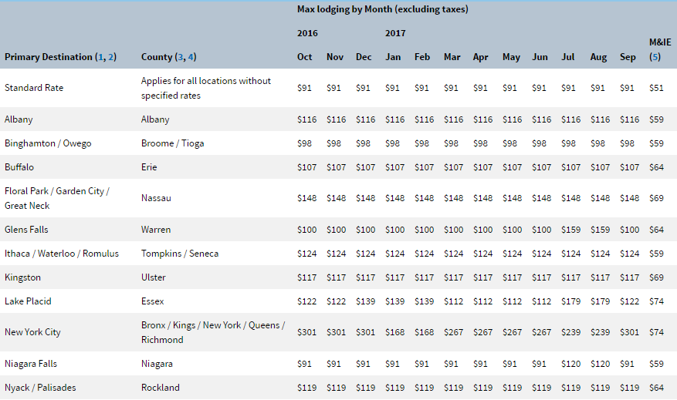
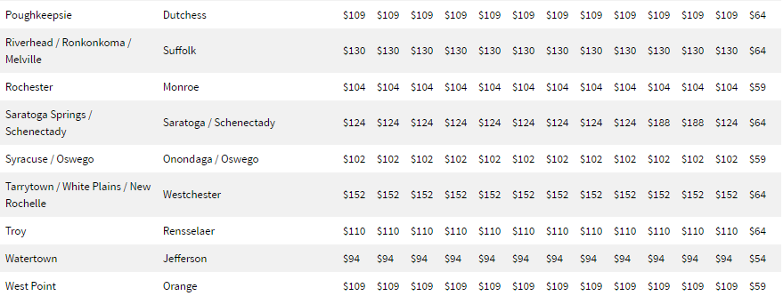

Examples of breakdown of per diem rates.

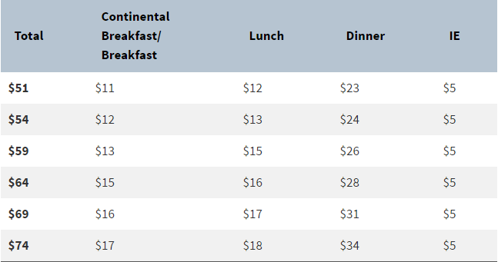

Travel Conference Details - Registration/Fees

Receipts required.

This includes conference registration and/or fees.

Travel Conference Details - Other Conference Fees

Receipts required.

This category could include books or tapes purchased for business use only. It could also include other miscellaneous fees that are paid separately at the conference.

Travel Conference Details - Miscellaneous:

Receipts and justification required.

This is an open category to cover any items or fees that do not fit into the above categories.

